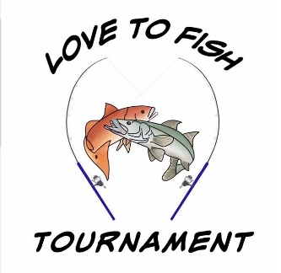
Hosted on May 18, 2024 at:
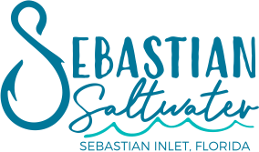
Sponsorship Levels
$200.00 Business on banner, recognition on our website & social media.
$350.00 Business on T-shirt & on Large Banner at Event plus recognition on our website & social media.
$500.00 & up Business on T-shirt, Business on Event Banner & exposure radio advertisement closer to the event and recognition on our website & social media. Plus your logo going on your choice of one of the promotional items handed out to all registrants and others at the event! (Water bottles, bags, sunscreen, ChapStick, fishing lure keychain, fishing bobbers, and foldable fishing nets.

We also need donations of raffle items/baskets….Any raffle items/gift card donations are greatly appreciated, and the business will get recognition on our social media as well as be mentioned at the Captains meeting and the tournament!

All proceeds benefit – Nonprofit Organization: Love to Serve, Inc.
All donations can be a tax deductible.
EIN # 84-3888298
Contact us at: lovetoserveirc@gmail.com or 772-584-1751

